**VMware -Accenture Certification initiative**

Prerequisites : -

* Vmware Partner central ID (eg: [shaju.kuttappan@accenture.com.vmw](mailto:shaju.kuttappan@accenture.com.vmw))
* Link to create -
* [https://www.vmware.com/in/partners.html](https://www.vmware.com/in/partners.html                            )
* VMware Training Center /Profile ID ( eg. [Shaju.kuttappan@accenture.com](mailto:Shaju.kuttappan@accenture.com))

Link to create - <https://mylearn.vmware.com/>

Steps for getting VMware Course and Voucher

**Requesting for Course:**

1. VCP-eligible e-learning course request link <https://in.accenture.com/delltechnologies/vmware-certification-campaign-e-learning-request/>
2. Enter your enterprise ID and select your course

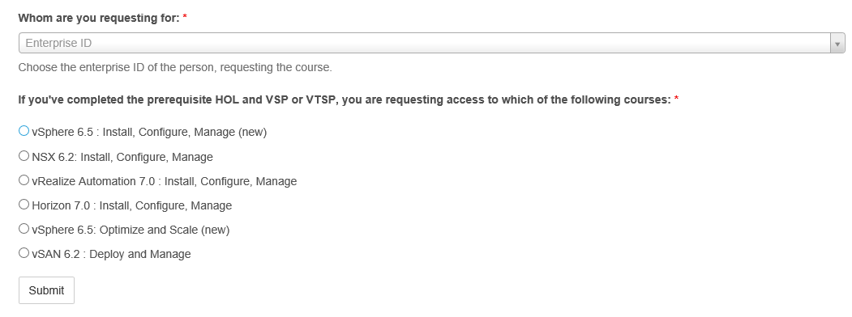

1. Select the course and submit

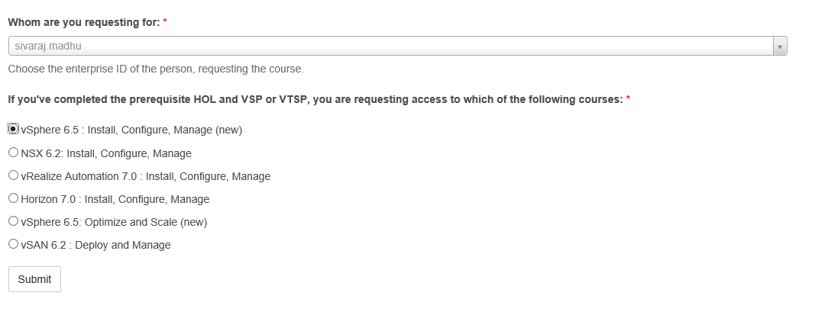

1. Once you submitted you will get below message

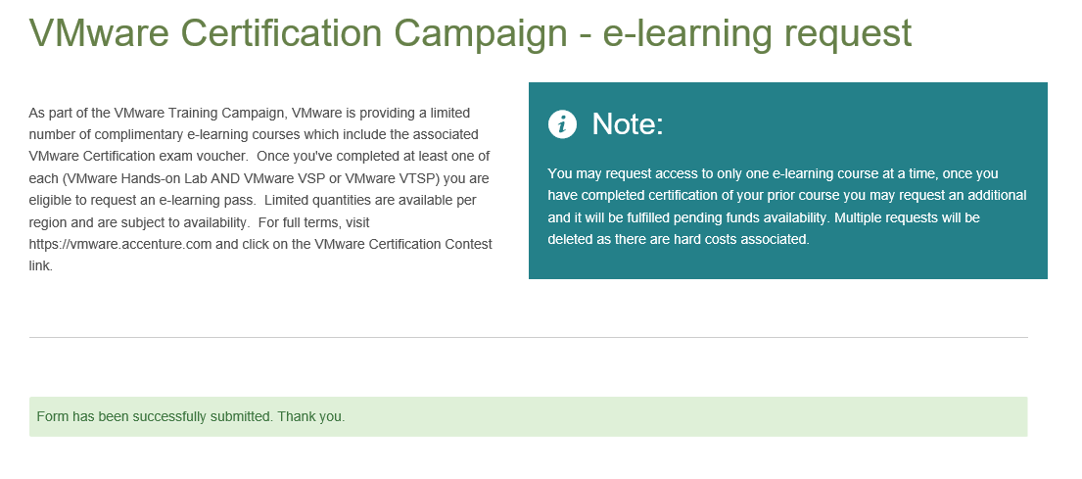

**Requesting for Voucher:**

**Existing User:**

1. Exam Voucher Request:

<https://in.accenture.com/delltechnologies/certification-exam-voucher-request/>

1. Enter your Enterprise ID, Candidate ID and Exam Code

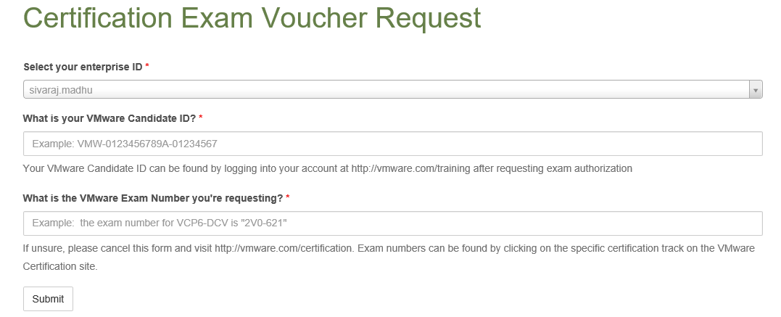

1. Candidate ID : you can get it from VMware

Login to VMware site- <https://www.vmware.com/in.html>

Select Training and provide your VMware Training ID and Password

Note: User ID should be Accenture Email ID

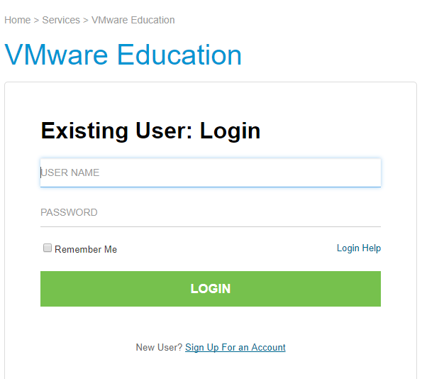

Once you are login to VMware training Site click profile.

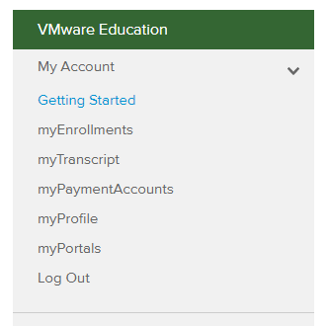

In the profile, down you can see the Candidate ID

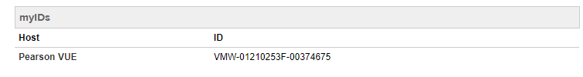

1. Exam Code:

1V0-601 VMware Certified Associate 6 - Data Center Virtualization Fundamentals

1V0-603 Certification VMware Certified Associate 6 - Cloud Management and Automation Fundamentals

1V0-621 VMware Certified Associate 6 - Data Center Virtualization

1V0-642 VMware Certified Associate 6 - Network Visualization Fundamentals Exam

2V0-602 vSphere 6.5 Foundations

2V0-620 vSphere 6 Foundations

2V0-621 VMware Certified Professional 6 - Data Center Virtualization

2V0-621D VMware Certified Professional 6 - Data Center Virtualization Delta

2V0-622 VMware Certified Professional 6.5 - Data Center Virtualization

2V0-622D VMware Certified Professional 6.5 - Data Center Virtualization Delta

2V0-631 VMware Certified Professional 6 - Cloud Management and Automation Beta

2V0-642 VMware Certified Professional 6 - Network Virtualization (NSX v6.2)

2V0-651 VMware Certified Professional 6 - Desktop and Mobility Beta

2V0-731 VMware Certified Professional 7 - Cloud Management and Automation

2V0-751 VMware Certified Professional 7 - Desktop and Mobility Exam

1. Once Entered all the details you can submit the request

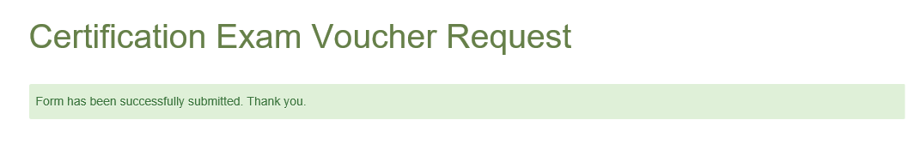

**New User Registration and getting candidate ID:**

1. Login to VMware site

<https://www.vmware.com/in.html>

1. Select training

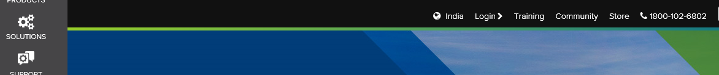

1. Select Login and then select Sign Up For an Account

Note: Email ID should Accenture ID

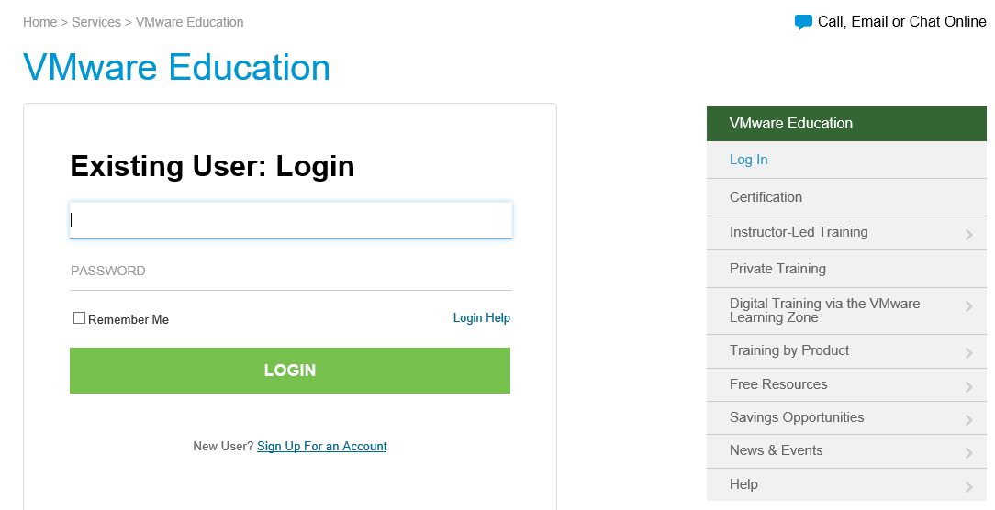

1. Once registered you can login VMware site using your registered user ID and Password

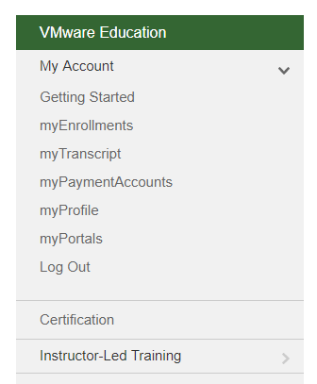

1. Click certification

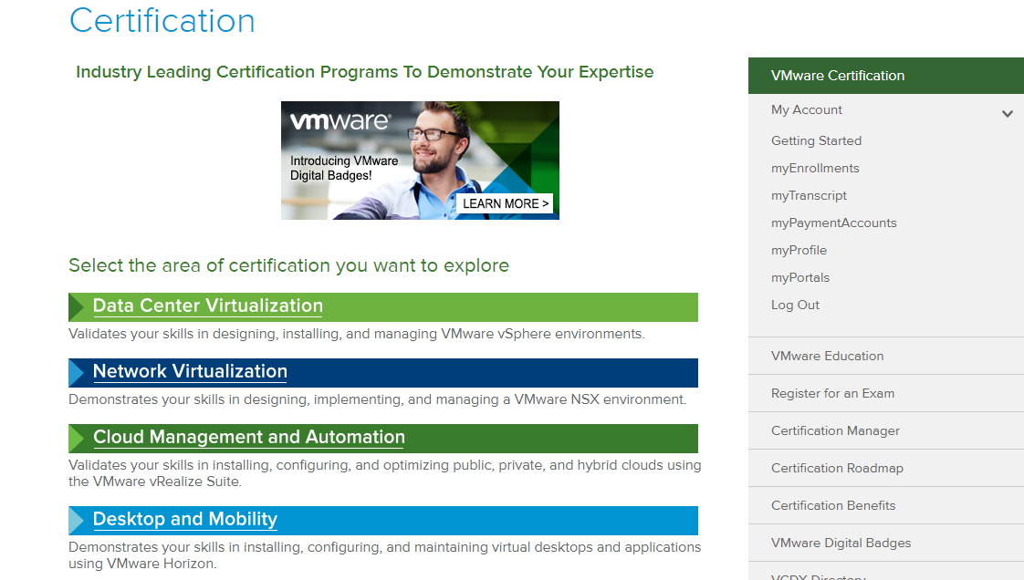

1. Select anyone certification exam

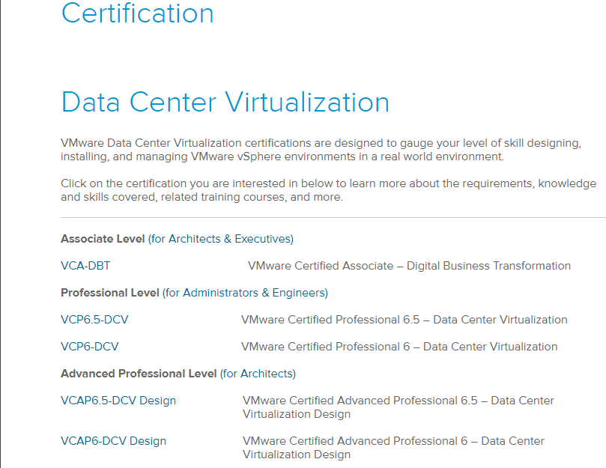

1. Expand the + and select VCP6.5 exam

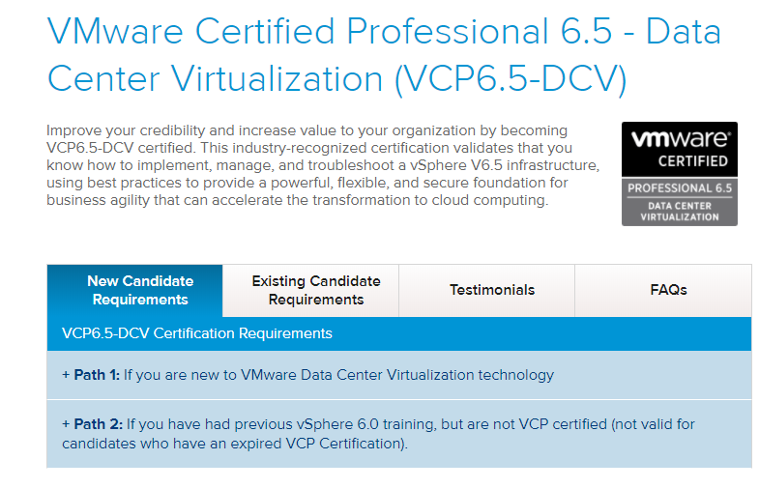

1. Register your Exam

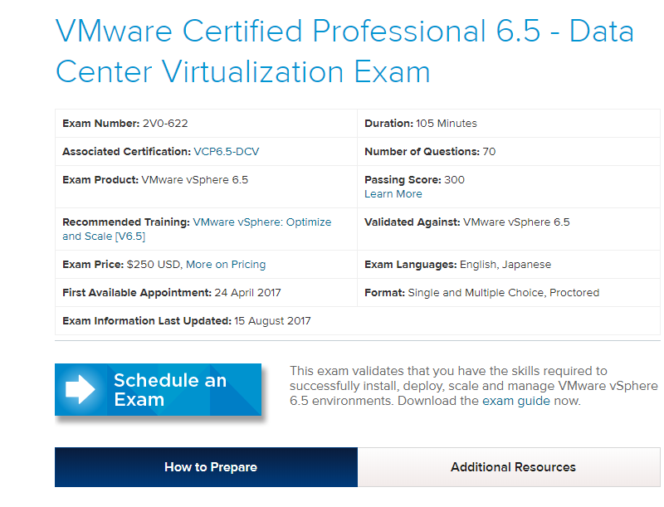

1. Then Click Confirm and Continue to Sigle Sign-On to Pearson VUE



1. Once Pearson VUE Site is open you can copy your candidate ID and then sign out.

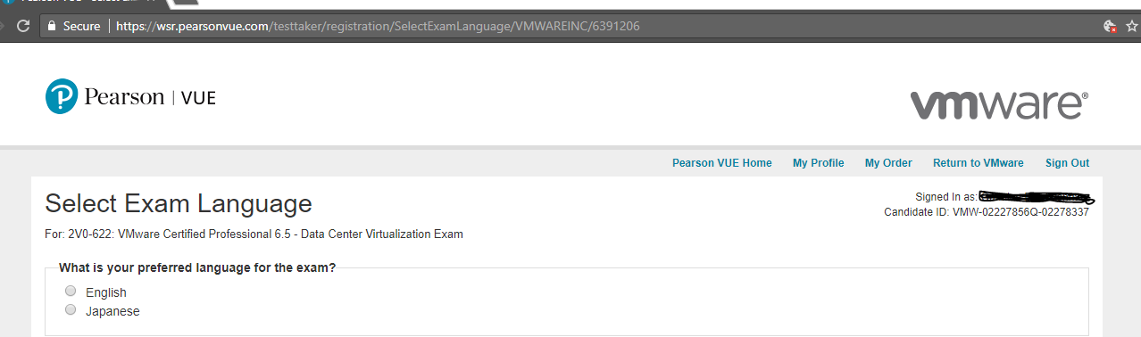

Once you get the Candidate you can login to certificate portal and request for voucher.